After Email Downtime Login Instructions

Logging into Microsoft Online Services Sign In (MOSS) Client
To complete the transition you will need to log into MOSS one last time.
- If MOSS does not auto-start, double click on the desktop icon. Sign in with your email address and password. | 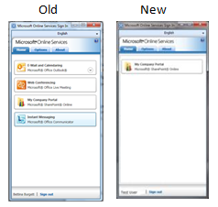  
- The login will complete, but you will no longer see the “Mail and Calendaring” and “Instant Messaging” icons.

- MOSS will soon stop launching when you start your computer – probably within a week or so.

Configuring Outlook
From now on, you will access your email by starting Outlook directly.
      - This can be done in one of two ways:
- Double-click on the Outlook icon on your desktop.
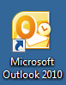
- Open the Start menu and click Outlook.
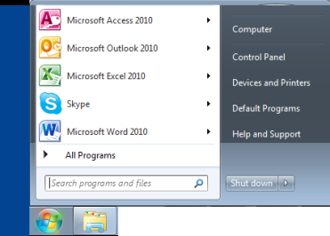
If it is not in your commonly used programs list, click All Programs > Microsoft Office > Microsoft Outlook 2010.
- You may be asked to select your Outlook profile, even if you only have one.  Select the profile with your project email address and click OK.  - You will then be prompted to log on to autodiscover. Enter your project email address (i.e., first_last@abtassoc.com) and your email password, then click OK. | 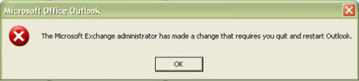  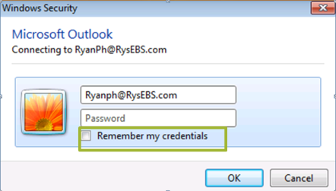  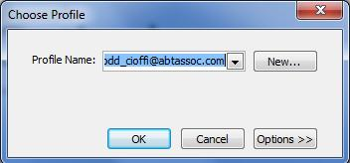
- Once connected, you will be prompted to exit and restart Outlook. Click OK.
- When Outlook restarts, as in Step 2 above, you may be asked again to select your Outlook profile.
- You will be prompted to log into Outlook server. Re-enter your email address (i.e., first_last@abtassoc.com and your email password, then click OK.

Removing the “Choose Profile” prompt
If you have been receiving the Choose Profile pop-up, and you have only one profile, the following steps will allow you to change your setting so that you won’t be asked this question in the future.
If you have not been receiving the Choose Profile pop-ups, or actually need to be able to select different profiles, you are finished with this document.
- From the Start menu, select Control Panel. | 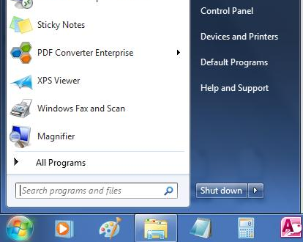
- Choose the View by option “Small Icons”. | 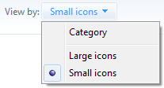
- Choose the Mail option. | 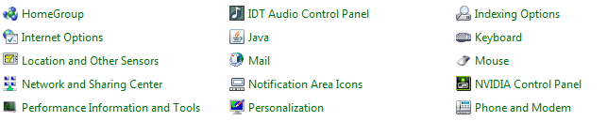
- When the Mail Setup dialog box appears, click Show Profiles…. | 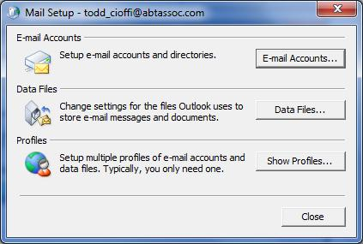
- In the Mail dialog box, select “Always use this profile” and choose your primary profile from the dropdown on the line below.  The primary profile should be your project email address.  Click Apply, then OK. | 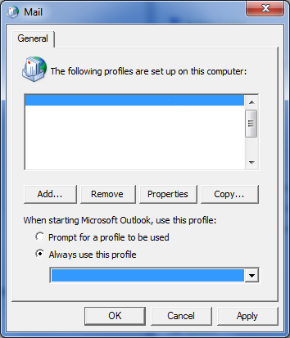
- Close the Control Panel dialog box. | 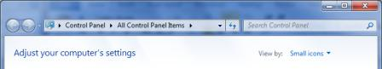
- Your profile configuration is now complete.

